PHYS 202 Test #2 (Version ___) Name __________________________________

***Do NOT cheat!!!*** Do NOT copy from someone sitting next to you … they have a different test.

Before starting the test, make sure there isn’t a page missing or misprinted.

Section A: ***TWELVE*** multiple-choice questions:

* Each is worth 2 points (unless you select “k”).
* Use your “Blue Book” to solve the problems.
* Circle only ***ONE*** choice for each multiple-choice question.
* Circling more than ONE choice will score ZERO out of 2 points (even if one of the circled choices is “k”).

1. A parallel plate capacitor consists of two conducting plates each with an area of ________ m2. The plates are separated by Strontium titanate (which has a dielectric constant of _____). 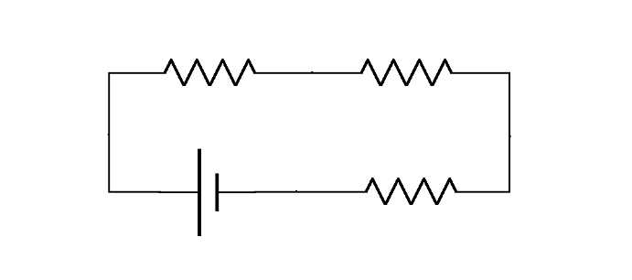
2. In the circuit shown above the ideal battery is ____ V and the resistors are ____ , ____  and ____ .

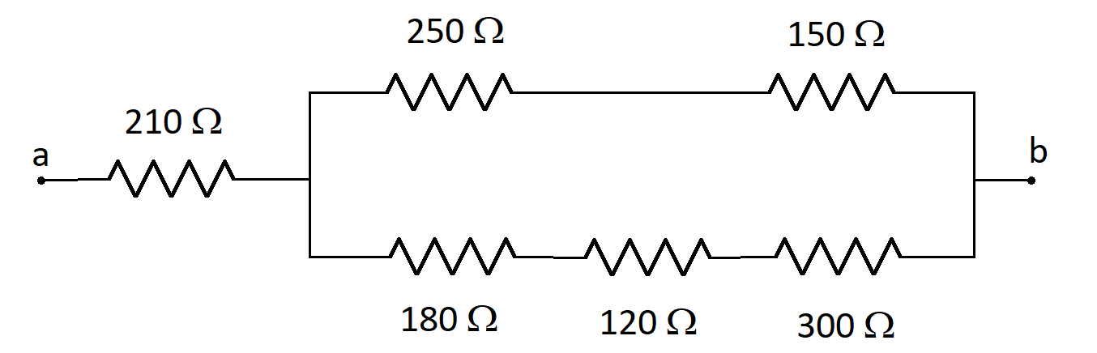

1. The combination of resistors show above is connected to a voltage source. If the potential difference across the ______  resistor is measured to be ______ V,

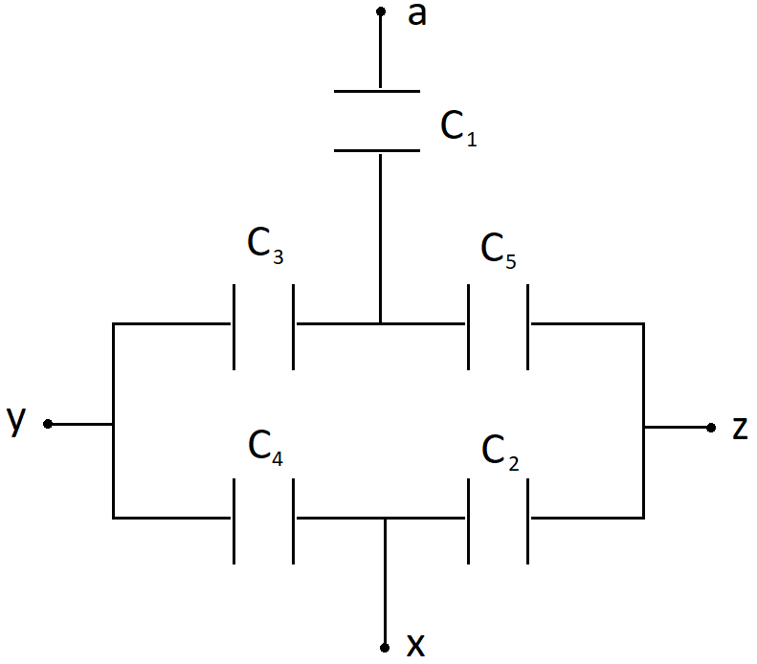

1. ________ What is the equivalent capacitance between points **____** and **_____**?
2. A copper wire has a radius of ______ mm and a length of ______ m. Taking copper to have a resistivity of ______ m at _____ °C and a temperature coefficient of _____ (°C) ‒1,
3. An RC series circuit consists of an unknown capacitor and a ______ k resistor. The combination is connected to a switch and a ______ V ideal battery. The current through the resistor is measured to be _____ mA ….
4. In the nasty circuit shown above, each of the emf’s is ______ V and each resistor is _____ . What is the value of the indicated current?
5. An air-filled cylindrical capacitor consists of an inner cylinder of length _____ cm and radius _____ cm …
6. An electrically charged particle passed through a velocity selector that has field strengths of _____ T and _____ N/C. After the velocity selector there is a region with a magnetic field …
7. A non-ideal battery has an emf of ____ V. When the battery is connected to a ____  external resistance …

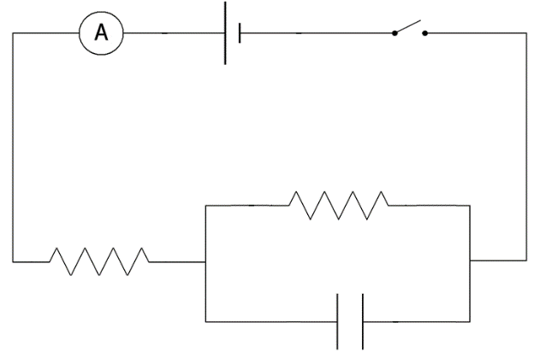

1. In the circuit shown above the emf is _____ V and the capacitor is initially uncharged. When the switch is first closed the ammeter reading is _____ A. After a very long time the ammeter reading is down to _____ A. If the capacitor is ____ mF, what is the maximum

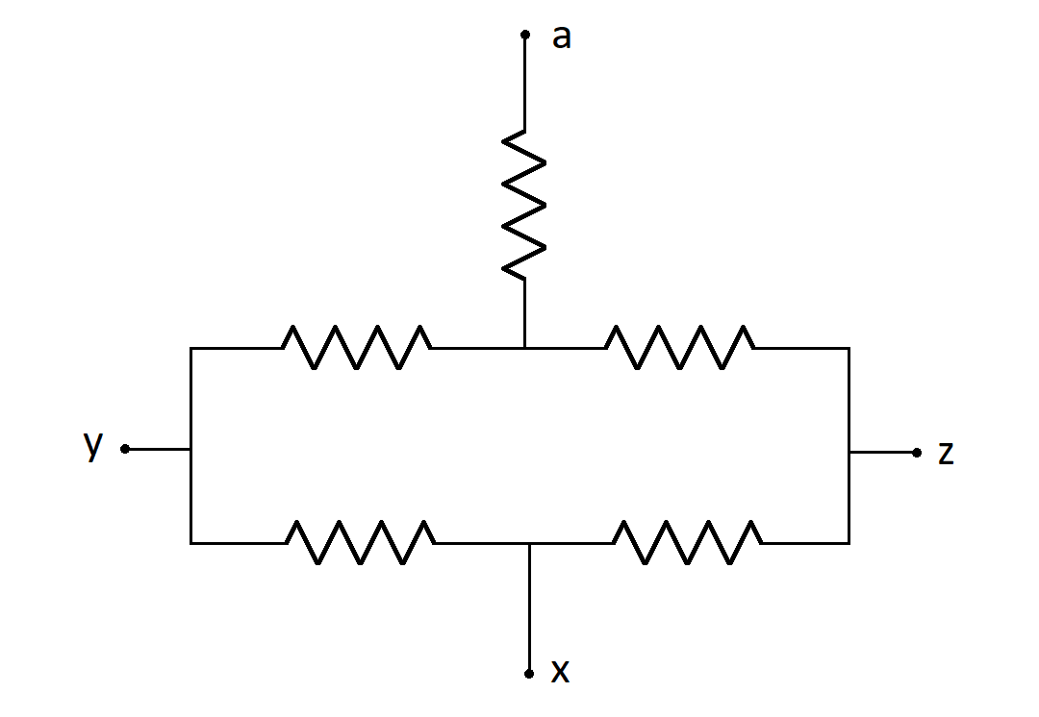

1. Each of the resistors in the combination above is ______ . A _____  resistor is connected between points **___** and **____.** What is the equivalent resistance between points **____** and **____**?

Set-up problems:

Each of the requested loops and junctions is worth 1 point.

